June 14, 2024

Stephen Barnes Esquire

Barnes Trial Group

1104 N Howard Ave.

Tampa, Florida 33607

Tel: (813) 251-0777

RE: *Kelli Knight and Michael Knight v Douglas B. Stalley, as Personal Representative of the Estate of Richard Homer Jacoby, deceased, Case No: 23-CA-001727, Circuit Court of the Sixth Judicial Circuit in and for Pinellas County, Florida, Civil Division*

Date of Crash: March 26, 2017

Date of Birth: *Kelli Knight:* May 21, 1974 [42 years old at time of crash]

Dear Mr. Barnes,

I am in receipt of your correspondence regarding the above-named action. I have reviewed the documentation accompanying your correspondence including medical records, information regarding the subject crash, litigation documents, and other materials, including the April 17, 2024, deposition transcript from the defendant's biomechanical expert, Dr. Ying Lu.

The purpose of this report is to assess the methods and conclusions of Dr. Lu as they pertain to the injury potential of the subject collision, relative to Ms. Knight’s post-crash diagnoses and treatment.

**My summary opinions in this matter are as follows:**

* **Dr. Lu's assertion that the subject collision did not have the capacity to cause or exacerbate any of the injuries indisputably diagnosed in Ms. Knight is lacking a foundation in science, medicine, or the facts in this case. Dr. Lu's opinions are based on a confusing and disingenuous presentation of a novel and distorted approach to causality and a misrepresentation and misuse of published literature.**
* **Dr. Lu's assertion that the subject crash only produced minimal and benign forces that could not have cause Ms. Knight's diagnosed spinal disk and other injuries because the forces in the collision were supposedly equal to those of ordinary and benign forces is not a reliable, relevant, or validated method of assessing injury cause. Using Dr. Lu's claimed delta V of 2.8 mph for the subject collision indicates significant occupant motion and forces that in no way resemble any of the absurdly innocuous comparisons claimed by Dr. Lu. Such comparisons are demonstrably unscientific and highly misleading, and irrelevant to any disputed issues in Ms. Knight's case.**
* **There is no scientific or factual basis for Dr. Lu's claim that Ms. Knight's previous spinal injuries could not or should not have been "exacerbated" by the subject crash. Indeed, Dr. Lu's use of the term is both meaningless and misleading, and neither she nor anyone else has the faintest idea of what forces would have been required to have caused Ms. Knight's previously diagnosed spinal disk and other injuries to become symptomatic, or to worsen. To suggest otherwise is frankly dishonest.**
* **The methodology and principles used by Dr. Lu to arrive at her opinions regarding the risk of injury from the crash to Ms. Knight are not scientifically reliable, either in general or as they were applied to the facts of this case. Despite a superficial appearance of scientific validity, Dr. Lu's methods are speculative, unscientific, and unreliable, and her conclusions are meaningless.**

*My qualifications to provide opinions concerning the matters herein, particularly on issues of the causal relationship between trauma and injury, are as follows:*

I am Professor and Chair of Forensic and Legal Medicine with the Faculty of Forensic and Legal Medicine of the Royal College of Physicians (UK), and a consultant in the fields of forensic medicine and forensic epidemiology. I am credentialed as a Fellow of the Royal College of Pathologists (UK), Fellow of the Faculty of Forensic and Legal Medicine (FFLM) of the Royal College of Physicians (UK) and member of the British Association in Forensic Medicine. I hold the following relevant academic degrees and certifications: a Doctor of Medicine degree (Med.Dr.) from Umeå University, a Doctor of Philosophy (Ph.D.) in public health/epidemiology from Oregon State University, a Master of Public Health (MPH) in epidemiology and biostatistics, also from Oregon State University, a master’s degree in forensic medical sciences (MScFMS) with the Academy of Forensic Medical Sciences in the United Kingdom, i.a. In addition to my degreed education, I have completed a 2-year post-doctoral fellowship in forensic pathology at Umeå University in Sweden and hold a Diploma of Legal Medicine (DLM) with the FFLM. I am also a fellow of both the American Academy of Forensic Sciences and the American College of Epidemiology. I am a Fulbright Fellow and held a 3-year roster appointment (2017-20) with the United States Department of State as a Fulbright Specialist in the field of forensic medicine. I serve as tenured Associate Professor of Forensic Medicine at Maastricht University and a joint Clinical Professor of Psychiatry and Public Health and Preventative Medicine at Oregon Health and Science University School of Medicine, where I have taught courses for the past 24 years in forensic medicine, forensic epidemiology, and injury epidemiology. From 2005-2017 I held an appointment as an Adjunct Professor of Forensic Medicine and Epidemiology at the Institute of Forensic Medicine, Faculty of Health Sciences, Aarhus University, Aarhus, Denmark, and am a recent (2020-21) visiting professor at University of Indonesia in the Faculty of Medicine.

I have been a crash reconstructionist since 1996 and have had ACTAR accreditation (the Accreditation Commission on Traffic Accident Reconstruction) since 2005. Over the past >25 years I have participated in the reconstruction of more than 3,000 crashes, including more than 300 fatalities. From 1999 through 2007 I served as a vehicular homicide investigator for law enforcement (consultant to the state medical examiner and special deputy sheriff), and I am a former affiliate medical examiner with the Allegheny County Medical Examiner’s office.

I am a member of the American Society of Biomechanics and have more than 60 scientific publications pertaining to injury biomechanics, including a book for the Society of Automotive Engineering and taught injury biomechanics in a faculty peer-reviewed course at OHSU for 15 years. I have served as a consultant on injury biomechanics to state and federal government.

I am an associate editor of the Journal of Forensic and Legal Medicine and serve or have served as an associate editor or editorial board member of 14 additional scientific peer-reviewed journals. I have published approximately 230 scientific papers, abstracts, book chapters and books on topics that include traffic crash injuries, crash reconstruction, injury causation and injury biomechanics, including the text for Elsevier, Forensic Epidemiology: Principles and Practice (2016). My publications have been cited by other authors more than 4,900 times.

I have provided testimony in more than 450 civil and criminal trials in state and Federal courts throughout the United States, Canada, and Australia. Please see my CV for further details.

**Background Facts:**

On March 26, 2017, Michael Knight was the driver with Kelli Knight was the passenger of a 2012 Harley Davidson FLTRX motorcycle stopped in southbound traffic on Gulf Boulevard, Indian Rocks Beach, Florida, when it was rear-ended by an unknown make or model car driven by Richard Jacoby. No police report was provided.

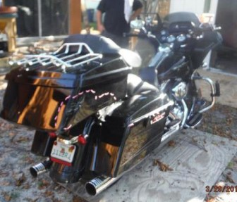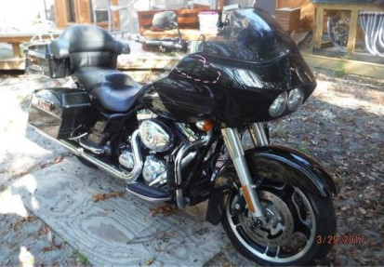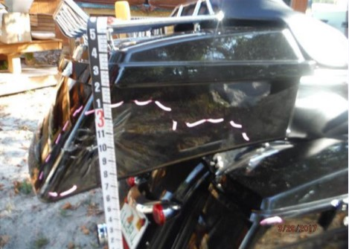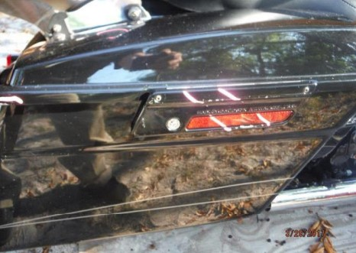

**Mr. Knight’s Harley Davidson motorcycle**

**Rental car driven by Richard Jacoby**

No damage estimate provided for Harley Davidson. Damage listed by Mr. Knight as rear fender, rear tour pack, right rear saddle bag, right exhaust and muffler, right inner and outer fairing, front fender. Not towed from scene.

No damage estimate provided for rental car. Provided images show scuffing to left headlight and edge of hood is bent. Not towed and no information on airbag deployment.

At the time of the crash, Ms. Knight was located on the back seat of the motorcycle. On impact, her body was thrown forward, possibly striking against the driver’s back. She began experiencing pain in the back of her head and neck, straight away, and she was shaken up. She headed straight home, on the bike, after leaving the crash scene due to not feeling well. When she got home, she felt shaken, dazed and in a lot of pain.

On March 27, 2021, the day after the crash, Ms. Knight commenced therapy with Dr. Michael LaRocca (chiropractic). She attended 4 times. Dr. LaRocca ordered cervical and lumbar MRIs, and she was referred to neurology and neurosurgery.

On March 29, 2017, Ms. Knight presented to Dr. Cecilio Torres-Ruiz (internal medicine) with complaints of pain in her neck and right lower back, left distal ankle pain and swelling; she also felt dazed, a sense of confusion and intermittent nausea. Cervical spine radiography revealed ligamentous instability. Dr. Ruiz diagnosed concussion syndrome, cervical/thoracic/lumbar spine pain, left ankle pain and muscle spasms, nausea and anxiety. He recommended physical therapy, and prescribed Meloxicam and Flexeril.

On March 31, 2017, Ms. Knight underwent an MRI of the cervical spine which revealed the following: at C3-4, 1 mm broad based left paracentral/posterolateral disk herniation with compression on the thecal sac, mild narrowing of the left neural foramen; at C4-5, asymmetric bulging annulus more prominent to the left of midline with compression on the thecal sac; at C5-6, 2-3 mm broad based right posterolateral disk herniation with compression on the thecal sac and extension into the right neural foramen and a 1-2 mm left posterolateral disk herniation with compression on the thecal sac, mild to moderate bilateral neural foraminal stenosis and intervertebral disk space narrowing.

On April 5, 2017, Ms. Knight underwent a lumbar MRI which revealed the following: disk bulging throughout the lumbar spine with spondylosis from L2-3 extending to L4-5; and levoscoliosis.

On April 7, 2017, Ms. Knight presented to Dr. Jeffrey Walker (neurosurgery) with complaints of pain in her neck, interscapular region, bilateral occipital headaches, right sided low back pain radiating into the right buttock and thigh; and difficulty with balance, memory, as well as confusion and altered taste. She also reported occasional burning in both hands. Dr. Walker diagnosed post-traumatic occipital neuralgia (bilateral), post-concussive syndrome, lumbar strain/facet syndrome. He expressed concern for the altered sense of taste/smell and encouraged Ms. Knight to follow up with neurology. He recommended cervical epidural steroid injections, bilateral occipital nerve blocks with persisting symptoms and discussed cervical microdiscectomy and disk arthroplasty if she developed neurological changes/radicular symptomatology. Dr. Walker also recommended obtaining a second opinion regarding cervical disk herniation and lumbar facet syndrome.

On April 10, 2017, Ms. Knight presented to Dr. Adam DiDio (neurology). She reported feeling dazed and confused immediately after the crash, with only a patchy recollection of events; and complained of daily headaches, nausea, photophobia, phonophobia, altered taste and smell, dizziness, imbalance, blurred vision, and occasional tinnitus. Ms. Knight also reported changes in cognition (difficulty concentrating, memory issues, feeling slow, fatigue, nervousness, and irritability). She also complained of neck pain, stiffness, right back pain and paresthesias in the lower extremities. Dr. DiDio diagnosed concussion (mild TBI), post-concussion syndrome, and cervical disk herniation; and ordered a brain CT scan/MRI.

On April 17, 2017, Ms. Knight underwent a CT scan of the brain which revealed the following: minimal mild frontal lobe atrophy.

On May 4, 2017, Ms. Knight underwent a brain MRI which revealed unremarkable brain parenchyma.

On May 9, 2017, Ms. Knight began therapeutic modalities with Dr. Phil Skandaliaris (chiropractic). She was referred for MRIs, neuro, and orthopedic consultations. Ms. Knight attended therapy through June 22, 2017.

On May 24, 2017, Ms. Knight returned to Dr. DiDio. She reported experiencing a near vasovagal episode while driving, migraine headaches 3 x/week, and occasional panic attacks. She also noticed some numbness in both hands. Dr. DiDio discussed neurocognitive testing at 6 months and prescribed Paxil 10 mg.

On July 5, 2017, Dr. DiDio referred Ms. Knight for occipital nerve block injections.

On July 10, 2017, Ms. Knight presented to Dr. Lora Brown (pain medicine, anesthesiology) with (right worse than left) neck pain, daily occipital headaches, and intermittent numbness in the right hand. Dr. Brown diagnosed a severe traumatic cervical spine injury resulting in a brain concussion, and lumbar spine sprain. She recommended diagnostic right cervical facet joint medial branch blocks progressing to radiofrequency nerve ablations as indicated.

On July 10, 2017, Dr. Brown performed a cervical epidural steroid injection at C6-7, followed by right cervical facet joint medical branch nerve block at C2-3, 3-4 and 4-5, on July 24, 2017.

On August 10, 2017, Ms. Knight presented to Dr. Victor Hayes (orthopedic surgery) with pain in the neck, mid-back pain and right leg, intermittent pain in the right arm, numbness and paresthesias in the right foot. Dr. Hayes noted Ms. Knight to be anxious, cooperative with a sluggish thought process. He diagnosed cervicalgia, thoracic spine pain and lumbago and recommended an anterior cervical discectomy and fusion (ACDF) at C5-6, with additional recommendations for right L4-5 epidural injections with medial and lateral branch neurotomy with persistent lumbar pain.

On October 2, 2017, Ms. Knight returned to Dr. DiDio. During the consultation she lost consciousness, briefly, witnessed by Dr. DiDio, preceded by feeling hot, sweaty, and shaky. She also reported a recent similar episode triggered by flickering lights. Dr. DiDio recommended neurocognitive testing and electroencephalography (EEG).

**On October 18, 2017, Dr. Hayes performed an ACDF at C5-6 with adjacent level stem cell injections at C4-5.**

On January 5, 2018, Dr. Hayes performed intradiscal stem cell injections on the right at L4-5, for pain relief. He discussed transforaminal discectomy at L4-5 with medial and lateral branch neurotomy with persisting symptoms.

On January 10, February 12, 2018, Ms. Knight returned to Dr. DiDio. She reiterated her complaint of altered taste and smell since the crash and reported another near vasovagal episode/focal seizure and frequent headaches. Dr. DiDio recommended proceeding with neurocognitive testing, brain MRI and EEG.

On March 1, 2018, Ms. Knight underwent neurocognitive testing with Dr. DiDio. The results evidenced major neurocognitive disorder secondary to traumatic brain injury (TBI); persistent post-concussion syndrome and mood disorder due to TBI with mixed anxiety and depressive features.

The brain MRI demonstrated several areas of significantly decreased brain volume predominantly lateralizing to the right, significant decreased brain volume in the left posterior superior temporal sulcus (more pronounced in the frontal lobe on the right)- findings suggestive of a TBI.

Dr. DiDio considered these deficits to be permanent.

On April 23, 2018, Dr. DiDio prescribed a trial of Keppra 500 mg twice daily.

On June 14, 2018, Ms. Knight revisited Dr. Hayes with persistent neck pain, occipital headaches, numbness in the right hand; mid and right sided low back pain radiating to the right leg and foot. She also reported post-op dysphagia and numbness in the left side of the throat. Dr. Hayes prescribed a Medrol Dosepak and recommended neurology follow up.

On June 25, 2018, Ms. Knight experienced another possible focal seizure while visiting Dr. DiDio. He recommended EEG as soon as possible, neuropsychological evaluation, and prescribed Clonazepam 0.5 mg.

On August 28, 2018, Ms. Knight underwent the EEG, performed by Dr. Erasmo Passaro (neurology) which revealed a normal awake stage 1 sleep EEG.

On September 24, 2018, Ms. Knight underwent comprehensive neuropsychological evaluation with Dr. Richard Hoffman (clinical psychology). Deficits were noted in visual spatial function, ability to sustain attention and auditory processing. She was also severely distressed and despondent about the future. Dr. Hoffman diagnosed mild neurocognitive disorder, severe depression and strongly recommended she pursue cognitive therapy.

On October 5, 2018, Dr. DiDio prescribed Adderall in addition to Clonazepam.

On November 29, 2018, Ms. Knight received a cervical epidural steroid injection.

On December 7, 2018, Ms. Knight underwent another cervical spine MRI which revealed: at C2-3, mild loss of posterior disk height; at C3-4, moderate loss of posterior disk height with mild degenerative retrolisthesis, broad based disk bulge (worse on left) with mild to moderate left sided neural foraminal stenosis; at C4-5, mild loss of disk height, broad based disk bulge with left paracentral extruded disk material extending down behind C5 (1.1 cm), mild to moderate left sided anterior/posterior canal stenosis; at C5-6, stand-alone cage, bilateral uncovertebral hypertrophy with moderate bilateral neural foraminal stenosis; at C6-7, moderate loss of disk height, mild broad based disk bulge with mild canal stenosis, mild left sided neural foraminal stenosis, suggestion of minimal extruded disk extending down behind the superior plate of C7 to the left of midline.

On December 10, 2018, Dr, Hayes discussed ENT referral for persistent dysphagia (possibly secondary to frontal lobe dysfunction as per Dr. Hayes). Dr. Hayes also recommended scheduling the lumbar spine surgery.

**On January 30, 2019, Ms. Knight underwent a transforaminal discectomy, right sided approach, at L4-5 and L5-S1, with L4, 5 and S1 medial and lateral branch neurotomy, performed by Dr. Hayes.**

On February 8, 2019, Dr. Hayes noted progressive adjacent level disk degeneration (above fusion at C5-6) and discussed undergoing a revision ACDF at C3-4 and 4-5.

On April 29, 2019, Ms. Knight returned to Dr. DiDio with complaints of increasing episodes of anxiety, dizziness, and tremors. He noted she was taking gabapentin (for the prior few months). Dr. DiDio increased the gabapentin dose to 600 mg three times daily, discussed repeating the EEG if the episodes continued.

On August 26, 2019, Dr. DiDio prescribed Zoloft. He recommended obtaining an extended EEG and discussed referral to Bay Area Neuropsychology for cognitive behavioral therapy.

On September 18, 2019, Ms. Knight reported an episode of amnesia lasting almost an entire day followed by 3 days in bed sleeping most of the time. Dr. DiDio reiterated recommendations for continuous EEG telemetry to further evaluate.

On January 29, 2020, Ms. Knight returned to Dr. DiDio. She had run out of medication (thus hadn’t taken any for a while) had a bad spell where she became unresponsive with pinpoint pupils about 3 weeks prior. Dr. DiDio diagnosed seizures and referred Ms. Knight to an epilepsy specialist for inpatient EEG monitoring. He prescribed Keppra 1000 mg, Clonazepam 0.5 mg and Zoloft 25 mg. She was advised to call 911 immediately if another seizure occurred.

On April 17, 2020, repeat cervical spine MRI revealed: postoperative changes at C5-C6 status post interbody fusion; broad-based disc herniations extending to the left at C3-C4 and C4-C5 with underlying disc bulges and spondylosis and mild thecal sac stenosis; and disc bulge with spondylosis at C6-C7 and C5-C6; multilevel lateral recess and foraminal narrowing from C3-C4 extending to C6-C7, moderate-to-severe on the left at C5-C6.

**On June 12, 2020, Dr. Hayes performed a revision approach, left anterior cervical discectomy at C3-4 and 4-5 with fusion.**

On October 22, 2020, Dr. Hayes administered intradiscal stem cell injections at L4-5 on the right.

On October 26, 2020, February 4, 2021, Ms. Knight revisited Dr. DiDio. She reported very few seizures, provoked by stress. (Brian MRI on June 9, 2021, demonstrated abnormal diffusion tensor imaging; significantly decreased fractional anisotropy values with an overall C-FAST score of 3-possibly indicating mild traumatic axonal injury).

On July 6, 2021, Ms. Knight underwent cervical medial branch block injections at C3-5, bilaterally for persistent neck pain, performed by Dr. Sea Lee (pain medicine, anesthesiology).

Ms. Knight revisited Dr. DiDio again for follow up on August 17, and October 5, 2021.

On April 5 and August 11, 2022, Dr. Lee performed cervical radiofrequency nerve ablations at C5-7 on the left (for persistent left sided neck pain). Height: 5 ft 4 inches, weight: 160 lbs.

*Pre-crash medical history*

Ms. Knight had a history of left trapezius tightness with periods of stress which would lead to migraine headaches. Tension migraines and chronic neck pain were treated with muscle relaxant medication and Topamax/Excedrin prescribed by Dr. Ronnie Hiemstra (family medicine).

Fractured collar bone aged 6 years

Carpal tunnel 1994/5

Ms. Knight sustained a closed head injury/concussion after a traffic crash (rollover) in 1989, aged 14 years. She incurred some brain swelling and short-term memory loss but made a full recovery.

Ms. Knight was also in a minor traffic crash in 2014 after which she underwent chiropractic evaluation secondary to pain in her lower back, neck, and shoulder.

Lower back pain since around 2008 following a lumbar sprain injury. Pain radiating into right lateral mid-thigh. Lumbar spine X-rays obtained, 2011 revealed a normal study.

*Medical and other records reviewed for history*

Kelli Knight, depositions

Crosswinds Physician Services, Dr. Freed

Premier Radiology (prior)

Professional health care of Pinellas, Dr. Hiemstra

Bulls Gap Medical Center (prior)

Tampa Bay Imaging

LaRocca Injury Centers

LaRocca Chiropractic Centers

Health Source of Tarpon Springs, Dr. Skandaliaris

Florida Physical Medicine (FPM), Dr. DiDio

FPM, Dr. Brown

Saint Pete, MRI

Florida Center for Neurology, Dr. Passaro (EEG)

Excel Medical Imaging

Elite Spine & Orthopedics, Drs. Hayes/Lee

Rose Radiology

Akumin MRI

Dr. Hoffman, records

Life Care Plan

**Opinions of defendant’s expert, Dr. Ying Lu (J.S. Held)**

Dr. Lu provided an opinion that the forces experienced in the subject collision by Ms. Knight are comparable to benign, non-injurious everyday activities. The basis for Dr. Lu’s opinions was primarily her comparison of the forces of the crash to those of daily activities, and citation to studies involving human volunteers, cherry picked from the literature to obscure the well-established actual risk of injury from the subject collision. Dr. Lu’s methods are aptly described as “junk science,” and her conclusion from the application of such methods utterly meaningless, irrelevant to any facts related to Ms. Knight’s health, and misleading.

Dr. Lu’s substantive conclusions can be summarized as follows:

* Based on crush analysis of the Toyota Yaris, she calculated the upper limit delta-V of the Harley Davidson was 2.5 mph (1.7 – 2.5 mph) and an upper limit impact closure speed of 2.8 mph (1.9 – 2.8 mph) with peak acceleration levels of 1.3 – 1.9 g’s for Ms. Knight’s lumbar spine and 2.6 – 3.8 g’s for her cervical spine.
* Dr. Lu’s described published experimental studies involving human volunteers as a basis for claiming no mechanism of injury existed.
* She claimed the forces of daily living, such as plopping into a low-back office chair, jumping forward from one stair riser to another, and a rear end collision in a bumper car, had comparable G forces as Ms. Knight experienced during the subject collision. But acknowledge the forces in those examples were more vertical than horizontal, as were experienced in the subject collision.
* Dr. Lu gave no opinions on injury causation.

*General comments on Dr. Lu’s approach*

The purpose of Dr. Lu's opinion is to provide a backdoor medical causation opinion that Ms. Knight was not injured in the subject collision because she (Dr. Lu) deemed any injury to be *impossible* in the crash. Dr. Lu made no attempt to assess the actual probability of injury from any real-world crash like the subject collision, information which can only come from observational (epidemiologic) study of injuries associated with real world crashes, not from intellectually dishonest comparisons between one of the most common causes of injury in the US to innocuous activities of daily living. Dr. Lu cites to multiple publications in her deposition, yet none of them provide valid or reliable evidence that the injuries diagnosed in Ms. Knight cannot, or did not, result from the collision that she was exposed to.

The generally accepted and peer-reviewed method of crash-related injury causation analysis for a specific individual is performed by assessing the risk of injury from the collision and comparing it to the probability that the injuries or conditions would have been present at the same point in time if the collision had not occurred. The process is referred to as a "3-step" injury causation method in which improbable alternative causes are ruled out and the single most likely cause is identified. The analysis is accomplished via the application of crash reconstruction, biomechanical, medical, and epidemiologic (risk assessment) principles.[1]-[2][3][4][5] This 3-step methodology has been extensively described in the peer-reviewed literature, been deemed generally accepted by Courts in the United States, and has been adopted as part of case law in the U.S.[6]-[7][8][9][10]

The three fundamental elements or steps of an injury causation analysis are as follows:

Whether the injury mechanism had the potential to cause the injury in question (aka general causation);

The degree of temporal proximity between the injury mechanism and the onset of the symptoms reasonably indicating the presence of the injury;

Whether there is a more likely alternative explanation for the occurrence of the symptoms at the same point in time (aka differential etiology).

Dr. Lu’s frankly absurd comparisons to everyday activities and volunteer crash tests in no way addressed whether the subject collision could have caused the injuries and sequelae observed in Ms. Knight, the first element of the causal analysis. Dr. Lu’s blanket denial that a mechanism existed in the subject collision for any of Ms. Knight’s diagnosed and persisting injuries is an uninformed assertion with no basis in science, medicine, or the facts in this case and does not constitute an assessment of the plausibility of her injuries resulting from the collision.

Dr. Lu has no information on the pre-crash condition of Ms. Knight’s spine, or any other part of her body. She couldn’t pick her out of a lineup and hasn’t the faintest idea of her tolerance to any type of trauma, including the subject crash. **The tolerance of an individual to forceful external loads is only defined once it has been exceeded,** not based on comparisons to studies of dissimilar forces applied to bits and pieces of dead bodies (part of the basis for Dr. Lu’s opinion). A review of all of the evidence in the subject case clearly established the fact that Ms. Knight’s tolerance was exceeded by the forces of the subject crash.

As Dr. Lu does not (and cannot) dispute any of Ms. Knight’s diagnoses, and she does not provide an alternative explanation for how her diagnosed injuries would have occurred at the same time as the collision, her analysis is incomplete, and fails to account for the undeniable evidence of injury following the crash.

The generally accepted 3-step approach to causation described above dictates that if there are no other contemporaneous competing causes for the injury that are more likely than an investigated plausible cause of the injury, then it is the investigated cause that is the most likely cause. Dr. Lu simply ignored Ms. Knight’s medical history like it never happened; her approach to "assessing" the cause of her injuries was to reject any evidence that she was injured in the first place. Dr. Lu doesn’t consider, much less mention the fact, that there are no plausible competing causes of Ms. Knight’s injuries occurring at the same time as the crash.

The concept of injury thresholds as a bright line below which no injury can occur is one that has been evaluated and rejected by the biomechanical community that is involved with the evaluation of occupant forces in motor vehicle crashes. Injury thresholds have nothing to do with the evaluation of real-world collisions and can never be used to deny the presence of a real-world injury following a collision. This is made clear in an SAE publication (J885) that summarizes human threshold data for use in government crash testing:[11]

"Such [tolerance] specifications are beyond the state-of-the-art in biomechanics except perhaps for a few academic situations. There are several difficulties which prevent a ready establishment of human tolerance levels. First, there are differences in judgment as to the specific degree of injury severity that should serve as the tolerance level. Second, large differences exist in the tolerances of different individuals. It is not unusual for bone fracture tests on a sample of adult cadavers to show a three-to-one load variation. Presumably, variations of at least this magnitude exist in the living population. Finally, most tolerance levels are sensitive to modest changes in the direction, shape, and stiffness of the loading source. The above considerations indicate that complete and precise definitions of human tolerance levels will require large amounts of data based on controlled statistical samples. Only in this way can the influence of age, size, sex, and weight be comprehensively assessed and only in this way can mean loads and statistical measures of scatter be linked to specific tolerance levels."

*Crash severity analysis*

*Reconstruction:*

Daylight, heavy pedestrian and vehicle traffic.

Kelli Knight, deposed February 27, 2019, testified she was the passenger on a motorcycle driven by her husband Michael Knight. They were on Gulf Boulevard in front of Crabby Bill’s, in stop and go traffic and were fully stopped when they were rear-ended by Richard Jacoby. Neither she nor Mr. Knight were wearing helmets.

Michael Knight, deposed February 27, 2019, testified he was the driver of his Harley Davidson motorcycle and was stopped in traffic due to pedestrians crossing the road. There were two to three cars ahead of him that were also stopped. He was about to start moving again when he got hit. His handlebars went to the right and his hand went through the fairing. He worked to keep the motorcycle upright as it was moved about five to six feet to the left. The motorcycle didn’t fall over and neither he nor Mrs. Knight came off the bike. Neither he nor Mrs. Knight were wearing helmets.

Richard Jacoby (deceased), deposed March 11, 2019, testified he was traveling southbound on Gulf Blvd in a rental car. He was traveling slowly because there was a lot of pedestrian and vehicle traffic. The motorcycle directly in front of him stopped suddenly and he collided with it. He saw minor damage to the motorcycle and no damage to the rental car. He estimated he was traveling 5 mph or less at impact.

All three testified police responded. No police report was provided.

Interrogatory response with Certificate of Service indicated as June 30, 2021, referenced Mr. Jacoby as deceased and Douglas Stalley as the Personal Representative of the Estate of Mr. Jacoby, and therefore Defendant.

*Analysis:*

Using a 2017 Honda Accord 4D sedan for unknown Jacoby vehicle. Basing impact speed on Harley’s post-collision travel distance of 5-6 ft. (as testified by Michael Knight).

**VC5 Results:** closing speed of 6-7 mph results in the Harley traveling 5.8-7.1 ft post-collision. **Harley dV 4.5-5.8 mph, peak g 3.3-4.3.** 200ms impulse, 0.3 restitution.

More info is needed on the Jacoby car to be more accurate.

*Can the injury potential of the subject collision be determined from crash testing of volunteers?*

Dr. Lu cited to human volunteer crash testing for her opinion that Ms. Knight could not have sustained any significant injury in the subject crash. The comparison between a real-world crash and the results of volunteer crash tests as a means of assessing injury causation is a practice that has been rejected by the relevant scientific and automotive engineering community as improper and unreliable. I have written and had published a number of peer-reviewed papers as well as a book on human volunteer crash testing and can state as a certainty that it is well established in the scientific literature that human volunteer testing (mostly crash testing) is not a valid basis for any determination of injury risk, probability, or cause in real world crashes. *There are no crash tests that have ever been structured like the subject crash (****rear impact of 5.8 mph delta V****), as it would be irresponsible to perform such a test.*

Earlier in this report I cited the SAE publication J885 as the basis for a quotation regarding absolute injury thresholds. This paper is an authoritative publication on the topic of human injury thresholds. In the section of the paper, on page 11, under *"4. Introduction to Biomechanics, 4.1 Test Subjects,"* is the following section:

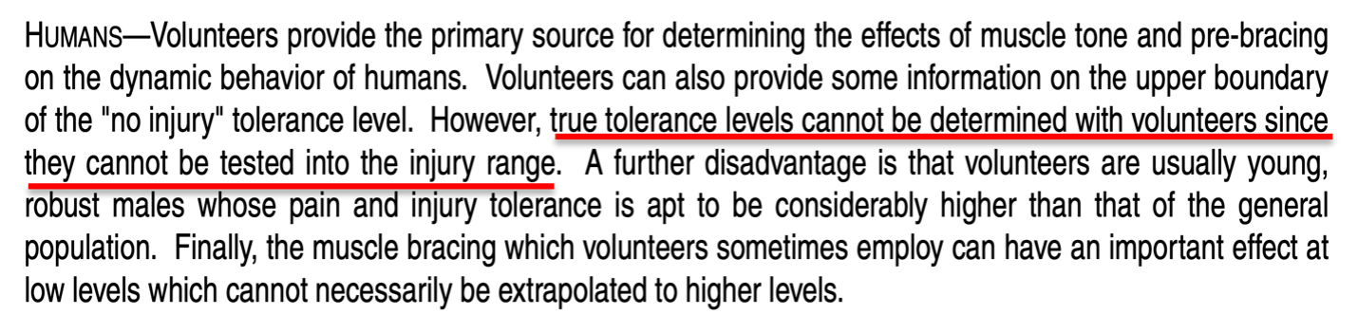

Despite the warning that "true tolerance levels cannot be determined with volunteers" from **the** authoritative publication on automotive testing and human tolerance, Dr. Lu described and referred to studies primarily consisting of single rear impact collisions of less than 5 mph (with no secondary frontal crash) on healthy male volunteers, and from these papers drew the conclusion that it was essentially impossible for Ms. Knight to have been injured in the subject collision.

Human volunteer crash testing is designed to *not produce injury*, and the utmost care is taken to ensure that injury is unlikely. The people who volunteer to participate in experimental crash tests are not comparable to those who are injured in similar crashes in many respects, and this includes the plaintiff. For any published crash test, the authors *typically* must secure Institutional Review Board (IRB) approval in order to assure the safety of the volunteers (this is in accordance with the Declaration of Helsinki, an international treaty on human subject experimentation).

As mentioned earlier, the peer-reviewed authoritative automotive engineering and biomechanical literature specifically states that crash tests are not an appropriate basis for any determination of real-world injury thresholds. In 1999 I published a peer-reviewed paper in the premier journal in the world on Spine surgery at that time (*Spine*), which specifically criticized some of the volunteer crash test publications cited by Dr. Lu in her report for erroneously claiming an injury threshold from such testing.[12] Dr. Lu presents no evidence to demonstrate that the basic scientific principles described in this 23-year old publication should be violated for her assertions regarding the cause of Ms. Knight’s post-collision diagnoses and need for treatment.

*Is any collision comparable to activities of daily living?*

As noted above, Dr. Lu claimed that the subject collision produced forces no greater than the loads observed in studies of "activities of daily living." Such comparisons are misleading and deceptive, and based on the junk science premise that if the occupant acceleration value of a crash can be said to be similar to that of some trivial sounding event, then this means that the injury potential of the crash and the trivial event is the same. This antiscientific myth has no application or use outside of the defense of injury litigation.

It should be patently obvious how ridiculous and frankly dishonest the comparison is between any collision and *any* everyday activity; there is no biomechanical similarity between a crash and an ADL. The direction, duration, and rapidity of acceleration that results in the kind of violent movement that occurs even in a low-speed crash is noncomparable in all respects to the self-generated, slow onset and long duration accelerations of daily activities.

The actual risk of injury from a lower speed crash is not determined by a comparison to an activity that never causes injury, of course. Such determinations are made by examining epidemiologic data regarding real world crashes and the types of injuries that result from them. This is precisely what my colleagues and I did in a recent peer-reviewed research publication, in which we noted the following:[13]

"…the theory that serves as the operating principle for the methodology, that acceleration is a proxy for injury risk in low speed or minimal damage crashes, which is the rationale for the comparison between a crash and non-injurious ADLs, is demonstrably false. Even at the lowest levels of impact severity in a rear impact crash, the results of both crash testing and epidemiologic data from real-world crashes indicate a substantial (i.e., >20%) risk of at least some degree of injury. **In contrast, everyday activities are benign events with virtually no injury risk whatsoever.**

**If the magnitude of the accelerations resulting from crashes and ADLs can be said to be even roughly comparable, this fact only serves as concrete evidence that occupant acceleration is not a proxy for injury risk."**

Regarding the novel nature of such comparisons as a basis for evaluating injury risk, we wrote:

**"There is no other example in the biomedical literature in which the established injury risk of any traumatic event is overlooked in favor of a comparison between the acceleration of the event and a non-injurious activity.** Although there may be multiple shared attributes of traffic crashes and some ADLs, just as there are multiple shared attributes of stepping down from a stair and falling down a stair (i.e., the travel distances are the same, gravity is 9.81 m/s2 in both scenarios), alluding to the absence of injury while ordinarily walking down stairs sheds no light on the frequency of injury from falling down stairs. **The comparison is inapt and should not be made."**

If we use the real world 11 km/h [6.8 mph] delta V rear impact injury risk from the present study (54%) and compare it to the highest estimated ADL-related risk (<<1 in 3,650 [0.027%] for sitting), **then even using the most conservative estimates, the crash presents a risk of injury that is at least 2,000 times greater than the "high risk" ADL of sitting.** This ratio likely underestimates the actual injury risk disparity between frontal-side impacts and ADLs by a factor of at least 10 times.

The National Highway Traffic Safety Administration (NHTSA) has recently published injury risk curves for rear impact crashes, demonstrating a rate of "MAIS 1+" (Maximum Abbreviated Injury Scale injury severity grade of 1 or more) injuries of 27% to 36% for 5 to 10 mph delta V rear impact collisions (see the red bracket in the chart below).[14] Approximately 94% of spinal disk injuries would be included in this category of injuries, as this is the rate at which disk injuries are initially diagnosed as strains in the emergency department in the first day or 2 after a crash, which is the source of the NHTSA data.[15]

The fact that Dr. Lu compared an event (a less than 10 mph rear impact collision) that is irrefutably established by US national crash data to cause injury at least 1 out 4 times to ADLs which virtually **never cause injury** is a perfect illustration of how misleading and frankly dishonest the comparison is.

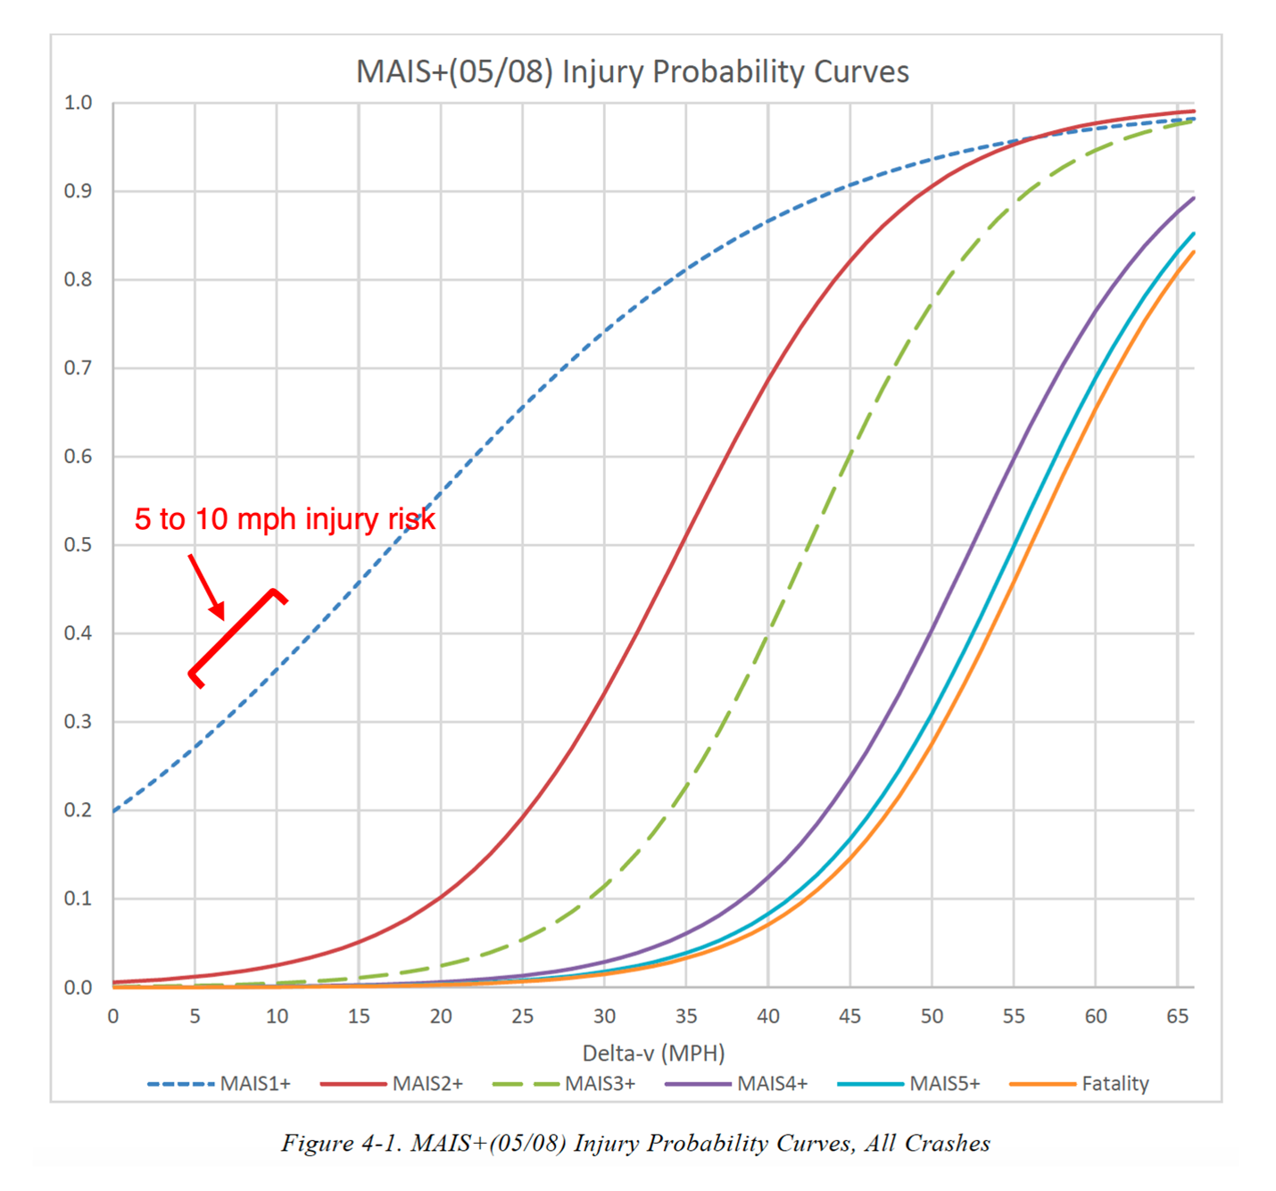

*Can a biomechanical analysis demonstrate that Ms. Knight was not injured in the subject crash?*

Traumatic spinal disk injuries have been described in the peer-reviewed literature as occurring in low to moderate force events, such as minimal damage traffic crashes and roller coaster rides, but also with even more mild forces, including therapeutic manipulation of the spine, and even sneezing.[16]-[17][18][19][20][21][22] It is accurate to state that there is no established or generally accepted lower force threshold at which it can be said that an acute intervertebral disk injury in any part of the spine cannot occur. Dr. Lu’s claims to the contrary are contrived and easily disproven, not to mention at odds with the specific facts in Ms. Knight’s case.

Dr. Lu’s offhand claim that a spinal disk could not be "exacerbated" by the subject crash (i.e., either symptomatically activated, or worsened) is a fantasy, with no theoretical, much less factual or scientific basis. In making this entirely speculative and meaningless claim, Dr. Lu engages in magical thinking, which collapses under the slightest bit of scrutiny.

In her report, Dr. Lu twice cited to publications on spinal disk biomechanics by a leading authority on the topic, Prof. Michael Adams. This very same author (Michael Adams PhD), in a 2012 textbook called "The Biomechanics of Back Pain,"[23] wrote that

"The magnitude of forces required to cause an individual disc to prolapse cannot reliably be predicted on the basis of gender, age, and spinal level." [page 263],

and that

"Most spinal compressive loading comes from back muscles, and forces are likely to rise to high levels during sudden and alarming incidents. These forces are difficult to quantify in retrospective analysis." [page 264],

and

"Clearly, to assume that the forces acting on the spine during whiplash are small just because the vehicle impacts are usually of low velocity would be a serious mistake. Muscle forces can be magnified in alarming situations, and if the muscles do not have time to react, then the underlying cervical spine is extremely vulnerable to bending." [pages 170-1]

It is clear that Dr. Lu’s approach to providing her opinions regarding Ms. Knight’s injuries is characterized by experts that she deems to be authorities in the field of spinal biomechanics as a "serious mistake."

**Conclusions**

Given the contiguous chain of causation from the day of the crash through Ms. Knight’s most recent medical records, the lack of any significant pre-crash history of persisting spine pain and need for treatment in the years prior to the crash, as well as the relative risk of significant and persisting spine injury from the subject frontal impact crash, I conclude that the most probable cause of the post-crash acute and chronic neck and low back injuries described in Ms. Knight’s medical records and summarized in this report, including her symptomatic cervical and lumbar disk derangements, is the subject March 26, 2017, low speed rear impact crash.

I have not examined Ms. Knight and I therefore have no opinions about her diagnoses, treatment, or prognoses outside of what is reflected in the medical record. This is not to say that I am not qualified, licensed, and extensively experienced in performing such evaluations, but that I have not done so in this case.

The preceding opinions were given as reasonable medical, and scientific probabilities. I reserve the right to amend any of my opinions should new information come to light.

Very truly yours,



Michael D. Freeman, MedDr, PhD, MScFMS, MPH, FRCPath, FFFLM, FACE, DLM

**David Jenkins Memorial Professor and Chair in Forensic and Legal Medicine**  
Faculty of Forensic and Legal Medicine, Royal College of Physicians (London, UK)  
  
**Associate Professor of Forensic Medicine,**  
Care and Primary Healthcare Research Institute, Faculty of Health, Medicine, and Life Sciences, Maastricht University, Maastricht, Netherlands  
  
**Clinical Professor of Forensic Psychiatry**  
Department of Psychiatry, School of Medicine, Oregon Health & Science University  
  
Fellow, Royal College of Pathologists (UK)  
Fellow, Faculty of Forensic and Legal Medicine, Royal College of Physicians (London, UK)  
Fellow, American College of Epidemiology  
Member, American Society of Biomechanics

1. Melia P et al. Development of the INFERENCE (INtegration of Forensic Epidemiology and the Rigorous EvaluatioN of Causation Elements) approach to causal inference in forensic medicine. Int J Environ Res Public Health 2020;17:8353; doi:10.3390/ijerph17228353.
2. Freeman MD, Zeegers M. Principles and applications of forensic epidemiology in the medicolegal setting. Law, Probability, & Risk 2015; doi:10.1093/lpr/mgv010.
3. Koehler S, Freeman MD. Forensic epidemiology; a methodology for investigating and quantifying specific causation. Forens Sci Med Path 2014 Jun;10(2):217-22
4. Hashish R, Badday H. Frequency of acute cervical and lumbar pathology in common types of motor vehicle collisions: a retrospective record review. BMC Musculoskeletal Disorders 2017;18:437
5. Freeman MD. A practicable and systematic approach to medicolegal causation. Orthopedics 2018;41(2):70-2.
6. Freeman MD, Centeno CJ, Kohles SS. A systematic approach to clinical determinations of causation in symptomatic spinal disc injury following motor vehicle crash trauma. PM R 2009;1(10):951-6.
7. Hashish R, Badday H. Frequency of acute cervical and lumbar pathology in common types of motor vehicle collisions: a retrospective record review. BMC Musculoskeletal Disorders 2017;18:437
8. Bunketorp O (2017) WAD – Criteria for Evaluation of Causality. Open J Trauma 1(3):054-063.
9. 35 F.Supp.3d 1360 United States District Court, D. Colorado. Donald L. Etherton, Plaintiff, v. Owners Insurance Company, a Michigan Insurance Company, Defendant. Civil Action No. 10–cv–00892– PAB–KLM
10. Etherton v. Owner Insurance Company. U.S. District Court of Appeals, 10th Circuit. Case No. 14-1164.
11. Freeman MD, Leith WM. Estimating the number of traffic crash-related cervical spine injuries in the United States; an analysis and comparison of national crash and hospital data. Accident Analysis and Prevention 2020: doi:https://doi.org/10.1016/j.aap.2020.105571.
12. Freeman MD, Croft AC, Rossignol AM, Weaver DS, Reiser M. A review and methodologic critique of the literature refuting whiplash syndrome. Spine 1999;24(1):86-98.  
    (NB this paper has been cited as an authority more than 220 times in the scientific literature – see https://scholar.google.com/scholar?hl=en&as_sdt=0%2C38&q=Freeman+MD+methodologic&btnG=)
13. Nolet PS, Nordhoff L Kristman KL, Croft AC, Zeegers MP, Freeman MD. Is acceleration a valid proxy for injury risk in minimal damage traffic crashes? A comparative review of volunteer, ADL and real-world studies. Int J Environ Res Public Health 2021 2021;18:2901; https://doi.org/10.3390/ijerph18062901.
14. Wang, J.-S. (2022, May). MAIS(05/08) injury probability curves as functions of delta V (Report No. DOT HS 813 219). National Highway Traffic Safety Administration.
15. Freeman MD, Leith WM. Estimating the number of traffic crash-related cervical spine injuries in the United States; an analysis and comparison of national crash and hospital data. Accident Analysis and Prevention 2020: doi:https://doi.org/10.1016/j. aap.2020.105571.
16. Giuliano et al. The use of flexion and extension MR in the evaluation of cervical spine trauma: initial experience in 100 trauma patients compared with 100 normal subjects. Emerg Radiol. 2002;9(5):249-53.
17. Freeman et al. Significant spinal injury resulting from low-level accelerations: A case series of roller coaster injuries. Arch Phys Med Rehab 2005;86:2126-30.
18. Lutz et al. CT myelography of a fragment of a lumbar disk sequestered posterior to the thecal sac. Am J Neuroradiol 1990;11(3):610-1.
19. Sadanand et al. Sudden quadriplegia after acute cervical disc herniation. Can J Neurol Sci 2005;32(3):356-8.
20. Pappas et al. Outcome analysis in 654 surgically treated lumbar disc herniations. Neurosurgery 1992;30(6):862–6.
21. Smith J. An analysis of 72 real world impacts - an initial investigation into injury and complaint factors. SAE Technical Paper 1999-01-0640.
22. Freeman MD. Medicolegal causation analysis of a lumbar spine fracture following a low speed rear impact traffic crash. J Case Rep Prac 2015; 3(2): 23-9.
23. Adams M et al. Biomechanics of back pain. London, UK, Churchill Livingstone, 2012.